**Logistic Regression:**

* Logistic regression is another supervised learning algorithm which is used to solve the classification problems. In classification problems, we have dependent variables in a binary or discrete format such as 0 or 1.
* Logistic regression algorithm works with the categorical variable such as 0 or 1, Yes or No, True or False, Spam or not spam, etc.

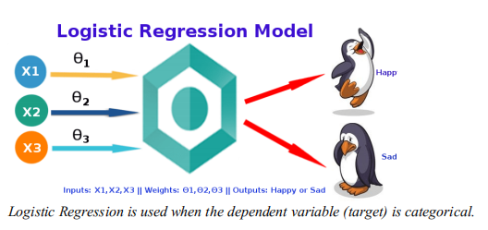

* It is a predictive analysis algorithm which works on the concept of probability.
* Logistic regression uses sigmoid function or logistic function which is a complex cost function. This sigmoid function is used to model the data in logistic regression.
* The function can be represented as:

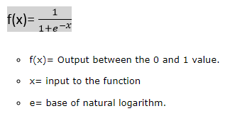

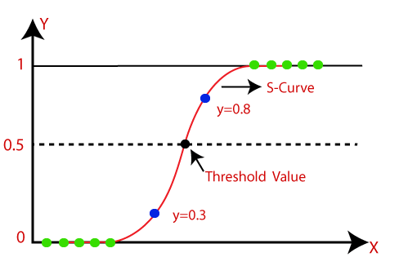

**Logistic Function (Sigmoid Function):**

* The sigmoid function is a mathematical function used to map the predicted values to probabilities.
* It maps any real value into another value within a range of 0 and 1.
* The value of the logistic regression must be between 0 and 1, which cannot go beyond this limit, so it forms a curve like the "S" form. The S-form curve is called the Sigmoid function or the logistic function.
* In logistic regression, we use the concept of the threshold value, which defines the probability of either 0 or 1. Such as values above the threshold value tends to 1, and a value below the threshold values tends to 0.

**There are three types of logistic regression:**

* Binary(0/1, pass/fail)
* Multi(cats, dogs, lions)
* Ordinal(low, medium, high)

from sklearn.linear_model import LogisticRegression

classifier = LogisticRegression(random_state = 0)

classifier.fit(xtrain, ytrain)

**Difference between Logistic and Linear Regression:**

* Linear and Logistic regression are the most basic form of regression which are commonly used.
* The essential difference between these two is that Logistic regression is used when the dependent variable is binary.
* In contrast, Linear regression is used when the dependent variable is continuous, and the nature of the regression line is linear.

**Key Differences between Linear and Logistic Regression**

* Linear regression models data using continuous numeric value. As against, logistic regression models the data in the binary values.
* Linear regression requires to establish the linear relationship among dependent and independent variables, whereas it is not necessary for logistic regression.
* In linear regression, the independent variable can be correlated with each other. On the contrary, in the logistic regression, the variable must not be correlated with each other.